1. **What is mongodb**?
2. Mongodb is most importantly a database but the company name is also mongodb.
3. **Origin of Name**: Now the name is stemming from the word **humongous** because this database is built to store lots and lots of data and not just from a data size perspective but also in a sense of you can store lots of data and you then work with it efficiently which of course also is super important.
4. This is Database solution. But we have got other DB solutions 🡺 MySql, Postgres etc. But how mongodb is different.
5. Of course Mongodb is database server which allows you to run databases on it.
6. In MySql we have **tables**, but in mongodb we have **collections**. Inside collection, we have **documents**.
7. Inside collection, we’re **schemaless**. This is really **flexibility** that mongodb gives you whereas Sql based databases are very strict about the data we store.
8. We can store totally different data in same collection and therefore, our db can grow with our app as our app needs it.
9. Of course you will have some type of structure in one **collection because** your app typically requires some type of structure with work with the data and in this course, we will have a whole module where we will talk about just data structure and relations.
10. Inside documents, you store JSON.  
    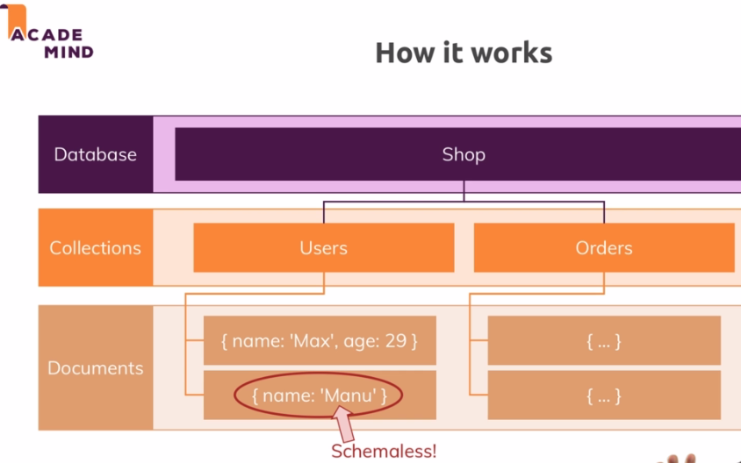
11. We use the format JSON and this is the document that looks like this 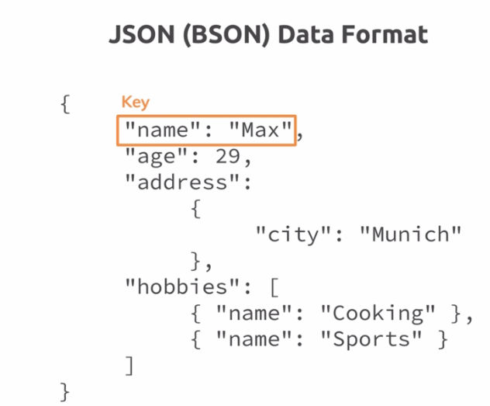 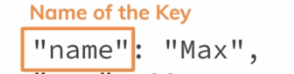 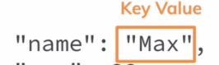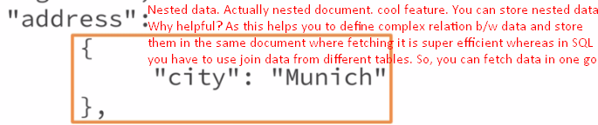
12. **BSON**: Mongodb converts this JSON data into binary version of it which can be stored and can be queried more efficiently.